PROJECT WORK

# PROJECT TITLE :- Comprehensive Digital Marketing For Noise

# NAME :- Gudisepogu Maneesha

# GROUP :- Bcom Computers

# COLLEGE :- Vasavi Mahila Kalasala

# UNIVERSITY :- Rayalaseema University

# MENTOR :- Gudisepogu Maneesha

# TEAM ID :- LTVIP2025TMID21797

INTRODUCTION

## In Today’s Digital Marketing refers to the online channels,tools,and strategies to promote products,services, or brands.

## It includes various forms such as social media marketing,search engine

## Optimization (SEO) , email marketing, content marketing, and paid

## Advertising.

## Unlike traditional marketing (TV, RADIO,PRINT) , digital marketing allows

## For precise audience, and personalized engagement.

# KEY COMPONENTS OF DIGITAL MARKETING

## 1.Search Engine optimization (SEO)

## 2.Content Marketing

## 3.Social Media Marketing (SMM)

## 4.Pay-Per-Click Advertising (PPC)

## 5.Email Marketing

## 6,Influencer & Affiliate Marketing.

## 

# . DIGITAL MARKETING FOR NOISE





# ADVANTAGES OF DIGITAL MARKETING FOR NOISE

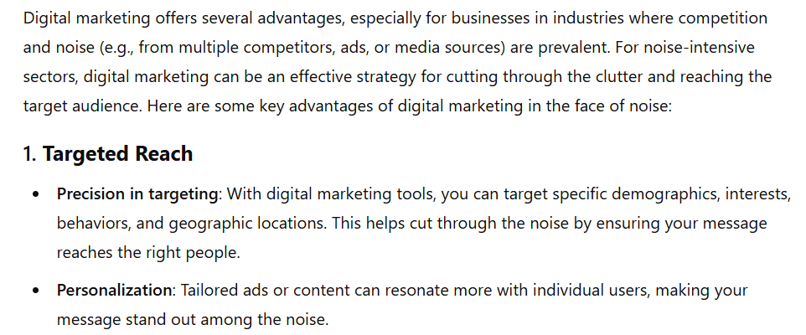

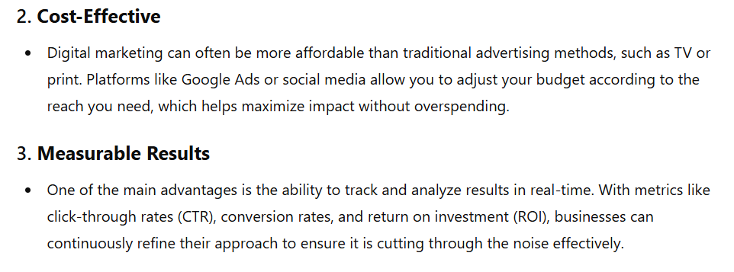



# DISADVANTAGES OF DIGITAL MARKETING FOR NOISE

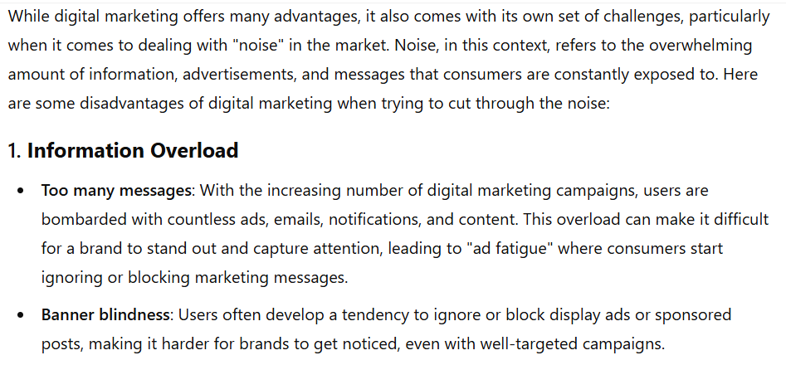

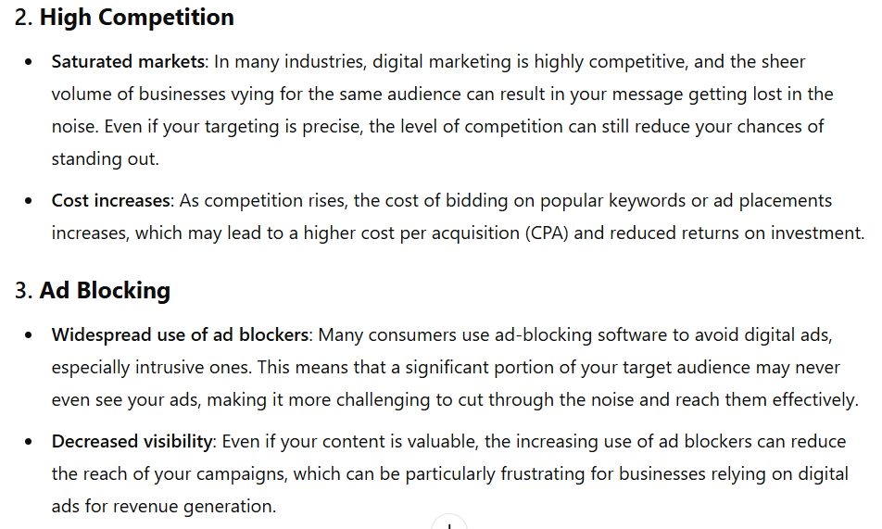



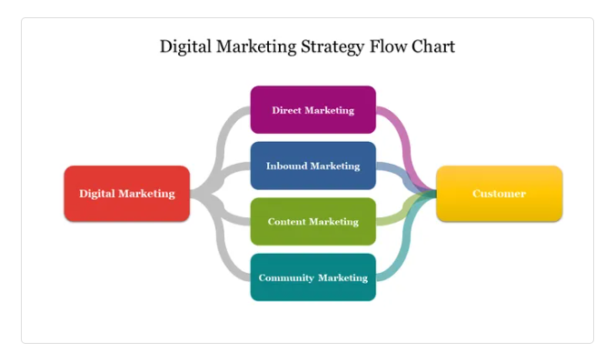

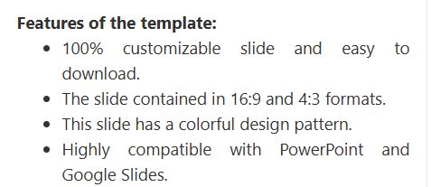

# COMPREHENSIVE DOGITAL MARKETING FOR NOISE

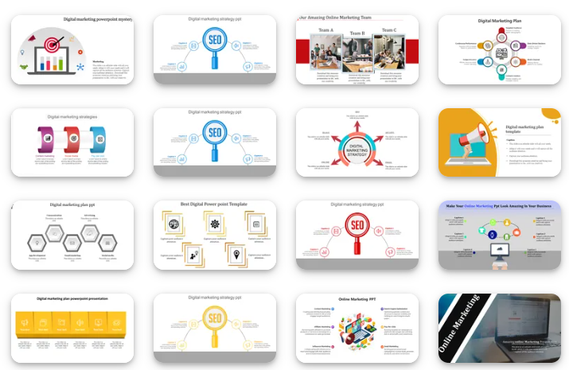





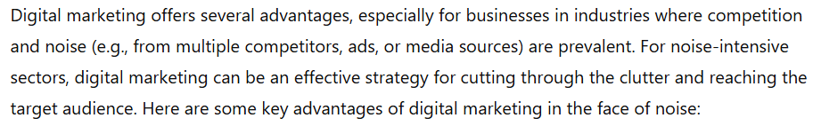

# IMPORTANCE OF DIGITAL MARKETING FOR NOISE

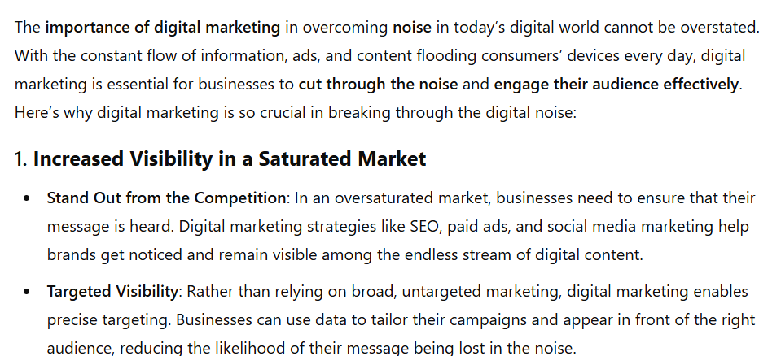

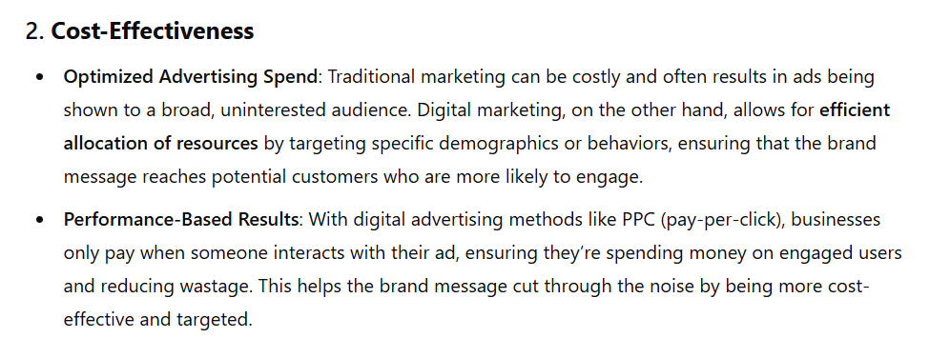

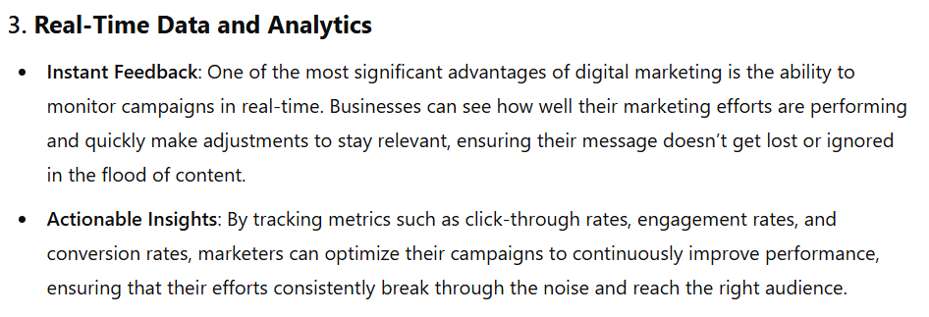

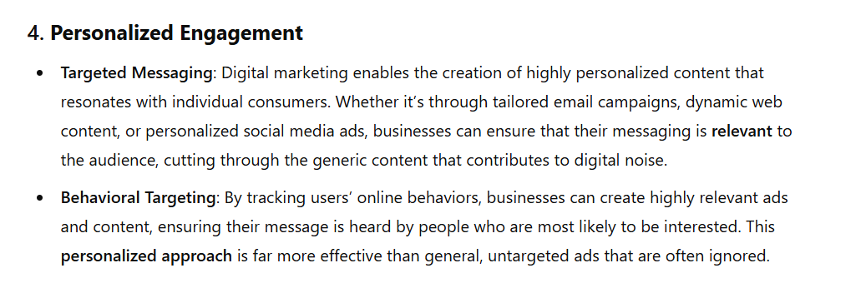

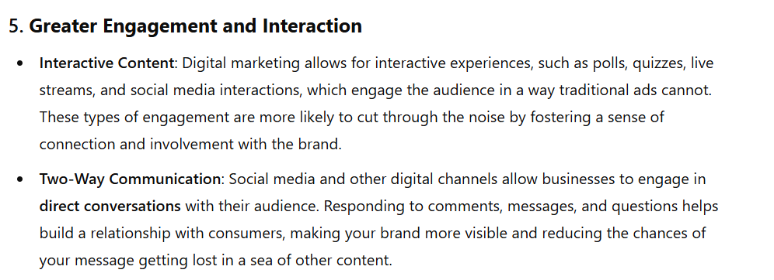

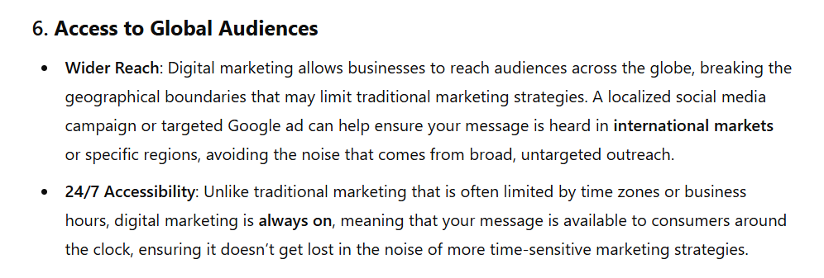

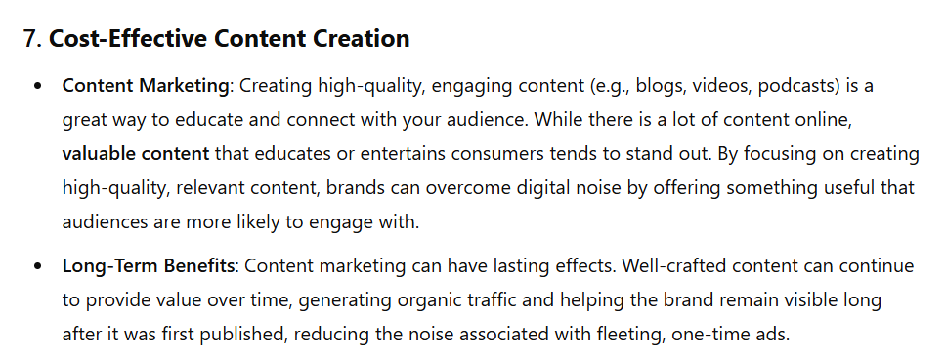

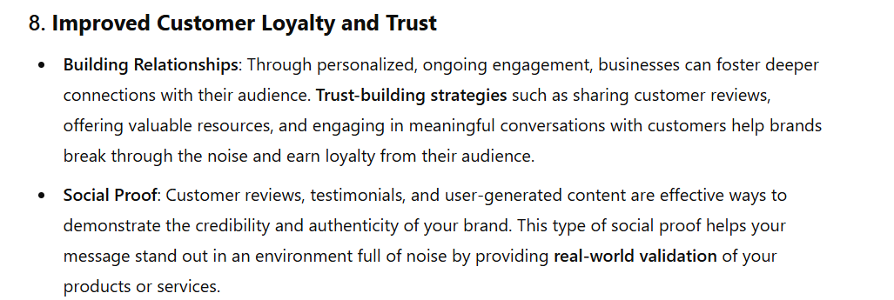

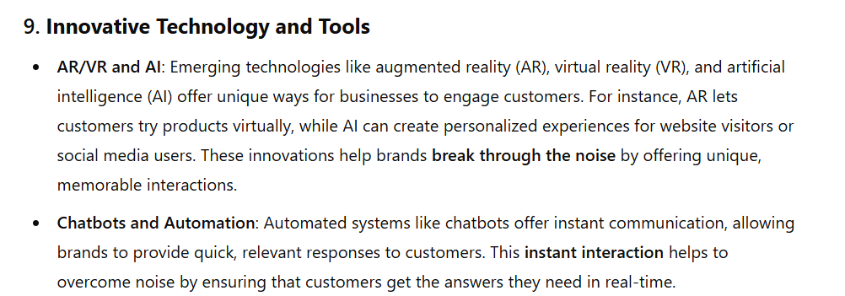

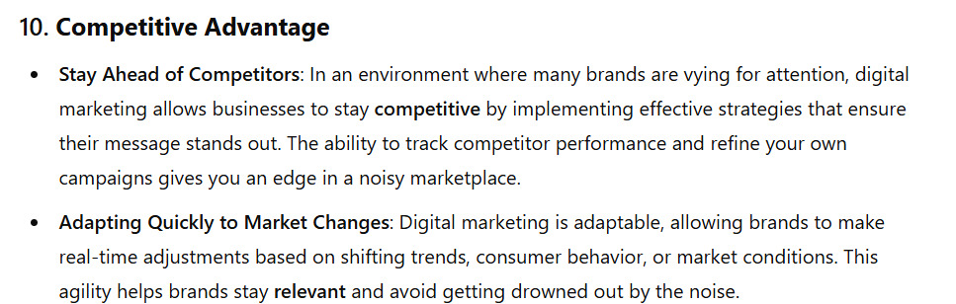







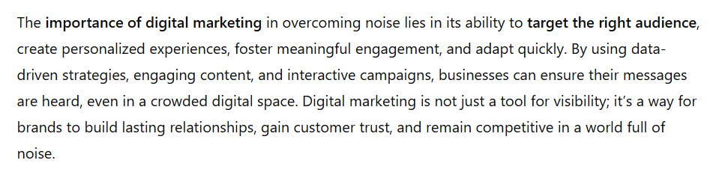





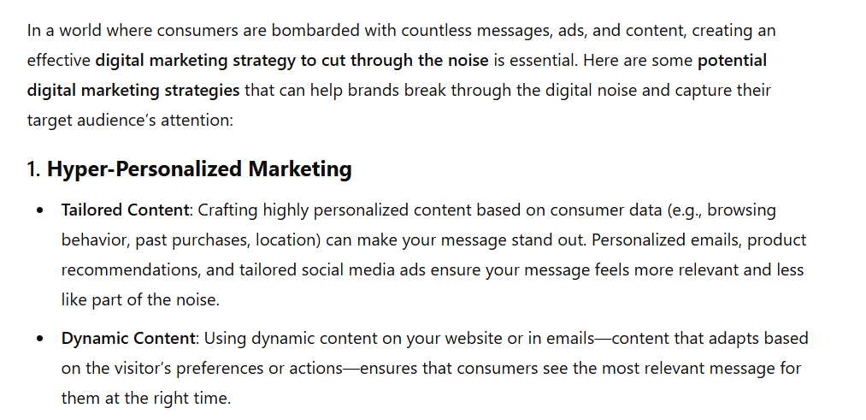

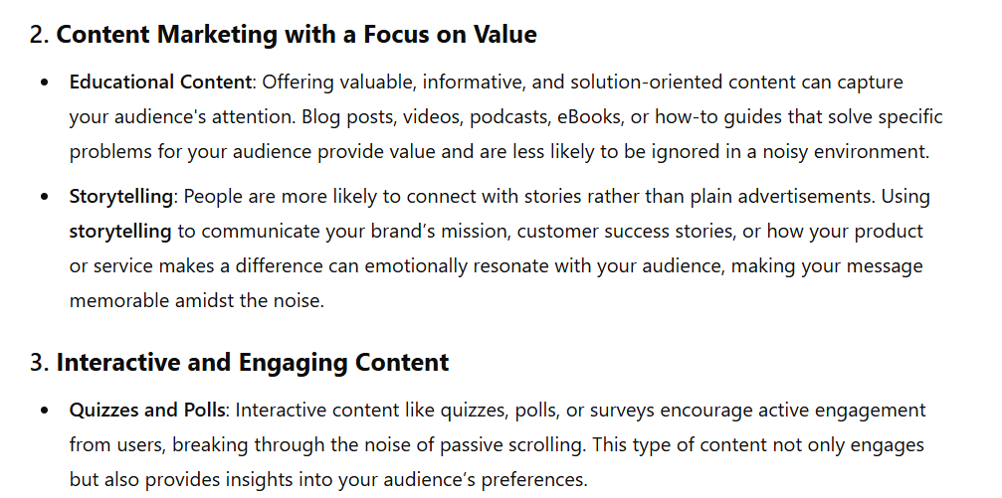

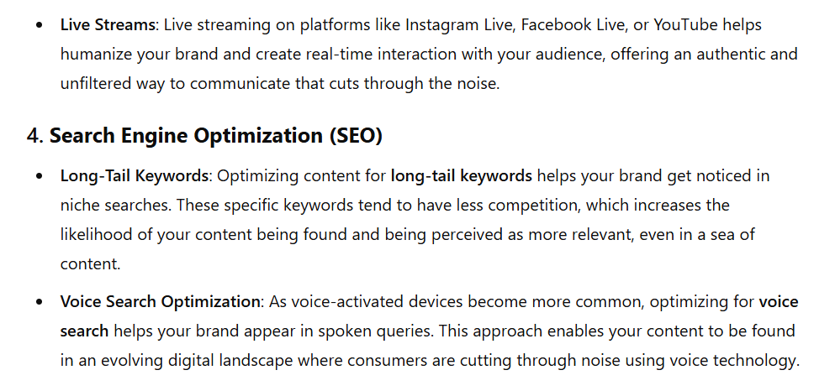

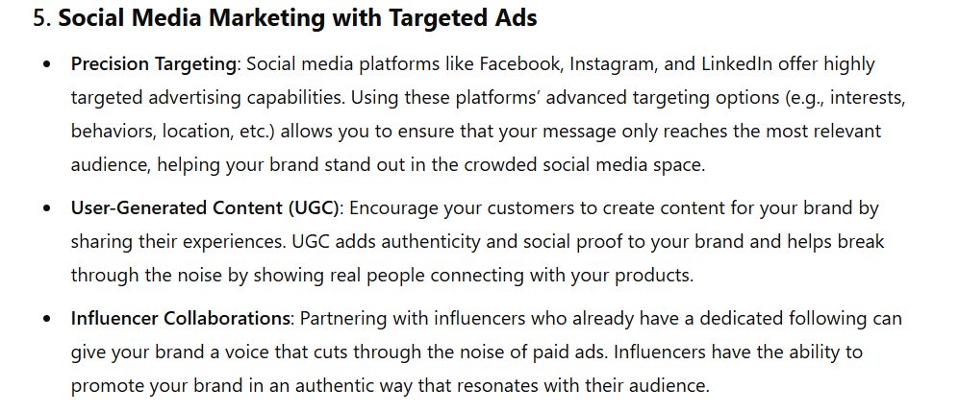



# CONCLUSION

